Virtualisation and Cloud Computing

M30203

UP2009045

2022

# Introduction

The aim of this lab book is to set up and document a cloud computing network using VMware and OpenNebula. This process will be documented in multiple sections beginning with the setup of the virtual machines for the network along with the network infrastructure based off the main host machine.

# Methodology

This section will document the preparation for the OpenNebula server using VMware, a commonly used virtualisation hypervisor which is also one of the oldest pieces of virtualisation software. I will be configuring one machine which will be on a bridged network (VP0-Bridged), this machine is premade and will have another machine within (VP0-NAT), which I will install and configure.

From this point I will clone VP0-NAT three times to create: VP1-Bridged, VP2-Host_Only and VP3-Custom, this is to test the network settings. For VP3 to have a valid internet connection, I will be installing and configuring OSPF routing on the host machine, VP0-Bridged.

# VMware Machines

## Network Setup

### Host machine network settings

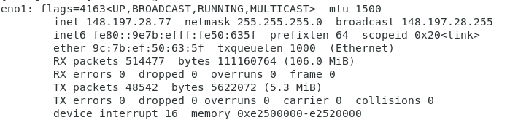

*Figure 1 - Network Card eno1 for Host System*

After booting into the host machine, I opened a terminal and entered the “ifconfig” command to display the network cards on the system along with their attached ip addresses, netmasks, broadcast addresses etc. This gives me the ip address I need to use for the bridged virtual machine within the host.

When bridging a network, the bridged network will be plus 100. In this case, the bridged network for my virtual machine will be 148.197.28.177.

### Virtual Machine Network Settings

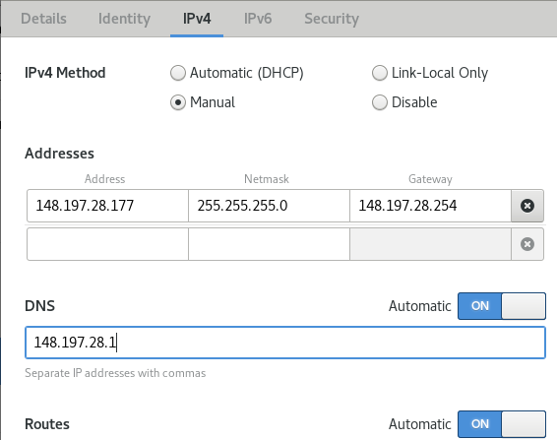

*Figure 2 - Wired Settings on VP0-Bridged*

Moving to the pre-configured virtual machine which I have opened within the VMware software, I navigated to the wired settings, selected manual for the IPv4 method and continued to enter the settings based on the host IP.

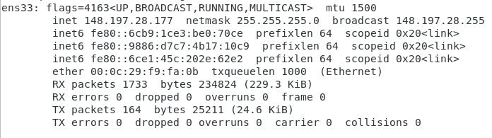

*Figure 3 - VP0-Bridged Test For IP Change*

Using the “ifconfig” command from within VP0-Bridged I could then see that the changes had taken place after turning the network card back on.

#### Testing network connection

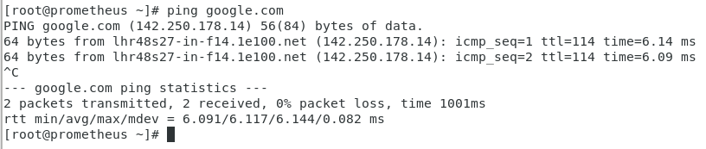

*Figure 4 - Testing VP0-Bridged Connection to Internet*

Pinging google.com from VP0-Bridged a successful connection was established showing the IP was configured correctly.

## OS Cleanup

Why is os cleanup important?

### Operating system update

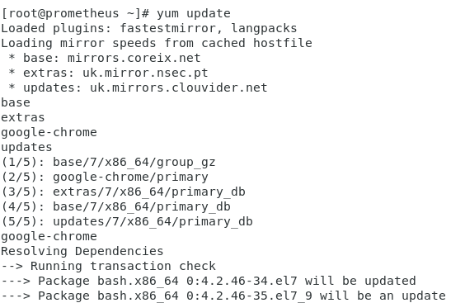

Running the “yum update” command will begin to run a full system update, updating all system packages, services etc, installs new packages and cleans up anything which is no longer needed, i.e. because it is out of date.

Network:

Host -> Client

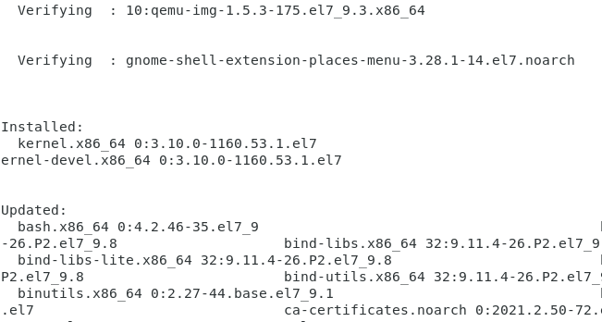

Once this section is complete it then verifies each file’s integrity and displays a list of programs which were installed along with programs which were updated.

During this process it is possible to get an error message because of PID Lock. If this is to happen, the command “kill -9” followed by the process id mentioned in the error message will shutdown the process that is causing the error message and allow the update to continue.

## Disabling SELINUX (Security-Enhanced Linux)

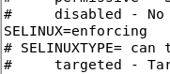

As standard, SELINUX is set as enforcing, which means that enhanced security features are active. When carrying out certain tasks on the system, for example when trying to work with SSL, this can interfere with processes and prevent them from working as expected.

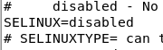

Using the command “gedit /etc/selinux” I edited the file, changing “enforcing” to “disabled” to disable SELINUX. After doing this typing the command “reboot” in terminal will restart the system enforcing the changes.

### Disabling Firewall

After disabling SELINUX, I then moved onto disabling the firewall as this can also cause problems when using some commands which involve the network.

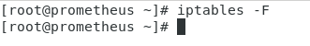

Using the command “iptables -F” will disable the firewall on the system simply by temporarily deleting the rules, however, this will need to be done each time the system is rebooted.

### Fixing Chrome Browser



As standard on CentOS, the chrome web browser does not open if the user is logged in as root. To fix this, I used gedit to open the google-chrome file in the bin folder.

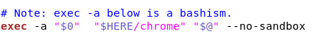

Adding in “-- no-sandbox” to the last line, after “$@”, will allow for me to use google chrome.

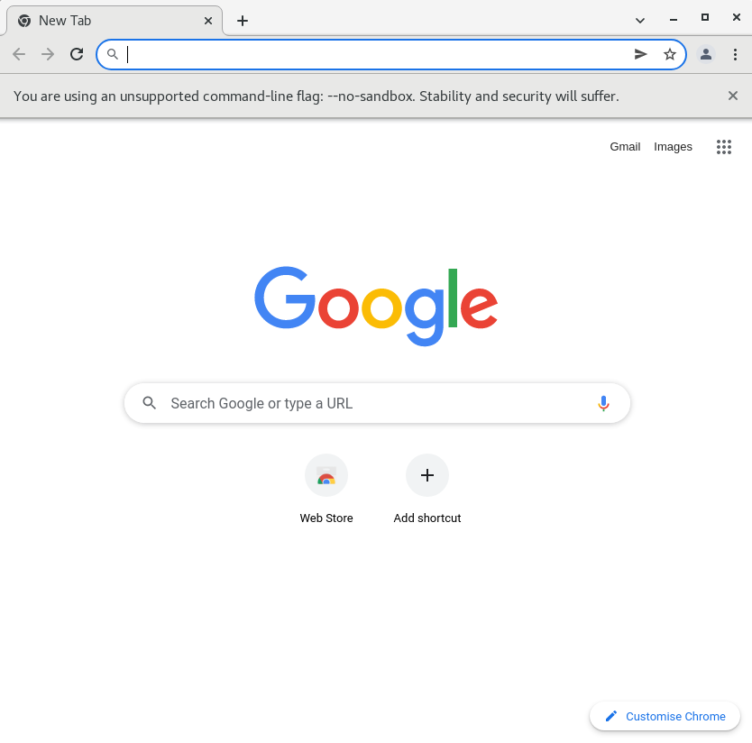

After editing the google-chrome file in the /usr/bin folder, I then opened the Chrome web browser which now works as expected

## VMware installation

Downloaded VMware-Player-Full-16.2.1.bundle file from the VMware website

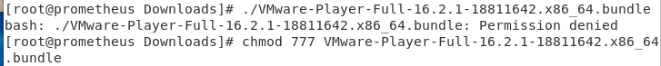

After downloading the file from VMware, I then attempted to run the file directly from the terminal but was presented with a “permission denied” error.

To remedy this I changed the permissions of the file using the “chmod” command and made the permissions 777, anyone has read, write and execute permissions to the file.

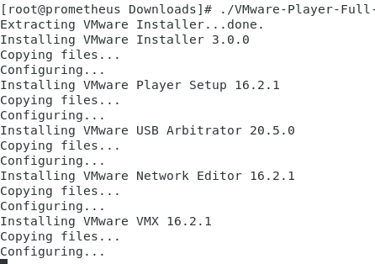

After changing permissions, I entered the command again to install the VMware package on VP0-Bridged where it then begins installation of VMware player.

### Copying ISO

Moving back to my host machine, I then used the “scp” command to copy my CentOS 7 iso from my Home directory to my virtual machine. This command uses an ssh connection and therefor required me to enter my machine’s password.

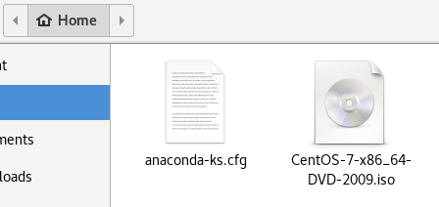

After copying over the CentOS7.iso from Host to Virtual Machine it can be seen in the VP0-Bridged Home folder. This image will be used for the creation of the aforementioned virtual machines.

### Setting up CentOS7 on Virtual Machine

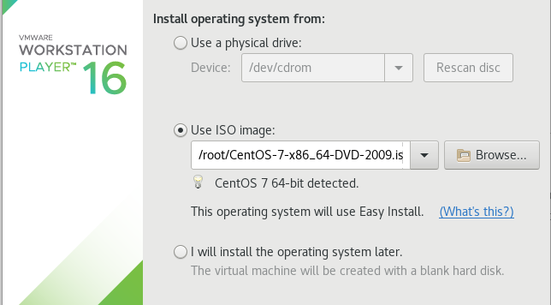

Following the standard setup process for VMware, I selected the ISO image that I was using along with the install destination. I then selected entered the machine name, username and password for the machine. For the amount of hard drive space I selected 10gb as I would not be using much space on this machine and after clicking finish, the virtual machine automatically installed and configured itself.

Explain the settings that I would normally get to choose

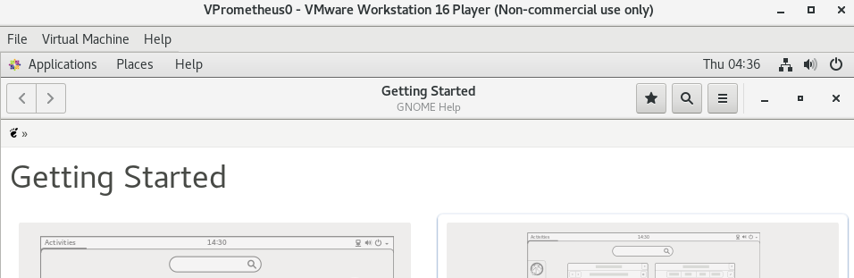

Once the installation process was complete, I then logged in as the root user and was presented with the standard “getting started” page showing that the install was successful.

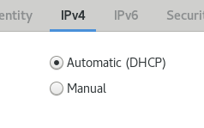

I then ensured the IPv4 settings were set to Automatic (DHCP) as this machine will be the VP0-NAT machine. Setting this to automatic will assign an IP address to the virtual machine from VMware.

## Editing the Hostname



Using gedit to open the hostname file, I can check what the current hostname for the virtual machine is, as standard this will usually be set to localhost.localdomain

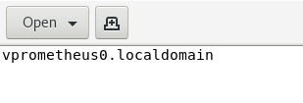

In my case, this was set to localhost.localdomain so I changed localhost to vprometheus0. For this change to take effect when using the terminal I will need to reboot the system as done previously when disabling SELINUX.

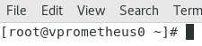

After rebooting the system, the hostname has taken effect.

## VIRTUAL MACHINE SETTINGS

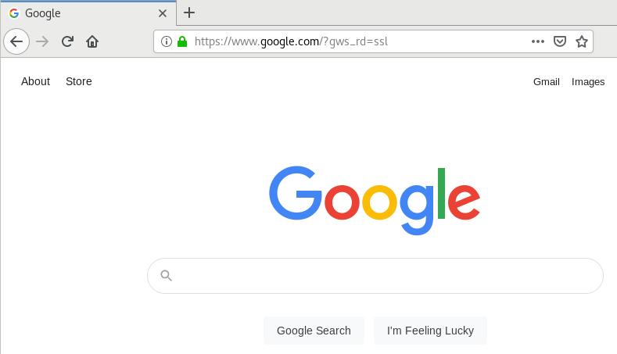

Google works as expected

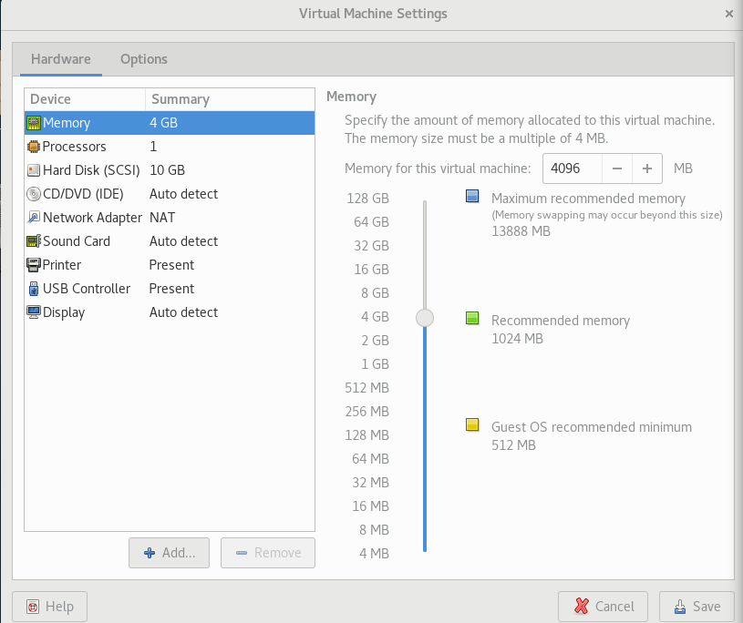

After changing the hostname, I then looked opened the virtual machine settings for VP0-NAT. The standard virtual machine settings for VP0-NAT consist of 4GB of ram, 1 processor and 10GB of virtual disk space

### Difference between suspended and powered off

The difference between powering off and suspending a virtual machine is when powering off a virtual machine, all programs, and processes currently active within the VM also gets shut down. When suspending the virtual machine, this puts the machine into a frozen state, pausing it and all current applications and process. This means that the user can resume from where they previously were, the suspend function in VMware is like the sleep option within the Windows operating system.

### Removable Devices

## Changing VM Settings

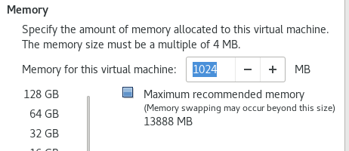

After testing the usability of the system to ensure applications and settings work, I again powered off the machine and moved back to the settings of the virtual machine. Originally the memory was set to 4096MB(4GB), I changed this to 1024MB(1GB). This will lower the amount of ram the virtual machine borrows from the host machine.

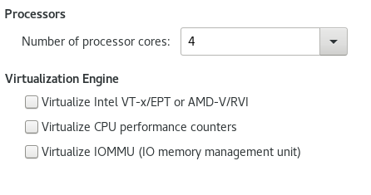

After changing the memory, I then moved to the processors tab which was originally set to use a single processor core for the system. I then changed this to the maximum amount the system would allow. VMware allows up to 16 cores, however, due to the host machine configuration 4 cores is the max that I could use in this instance.

### Virtualisation Engines

Intel VT-x/EPT AMD-V/RVI

CPU Performance Counter

IO Memory Management Unit

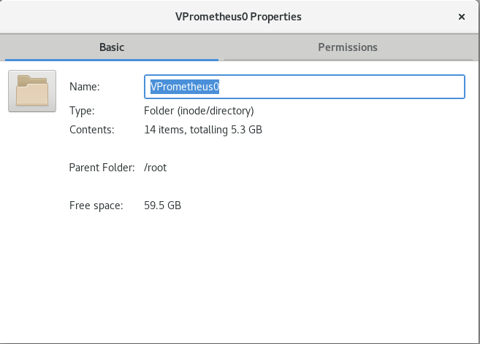

After configuring and testing the memory and processor settings, I checked the total size of files in the vPrometheus0 folder. The free space for this machine is set to 10GB and the current contents is 5.3GB

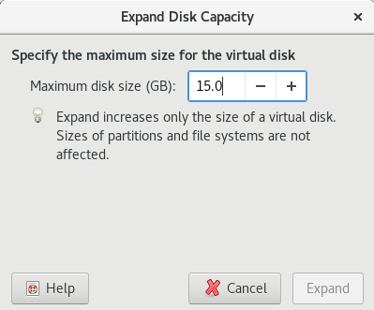

Moving back to the virtual machine settings for VP0, I expanded the virtual disk space to 15GB

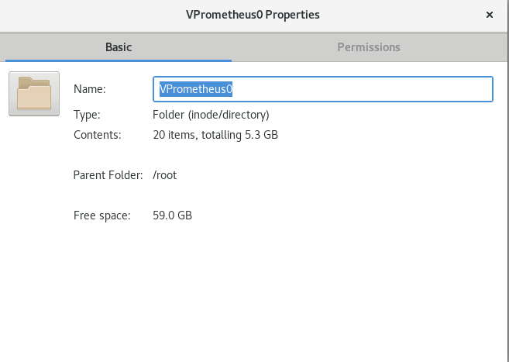

After changing the size of the HDD, the contents size stays but the number of items in this folder has increased, the virtual machine will not take up all the space it has been allocated if it does not need to.

## VMware Default Networking

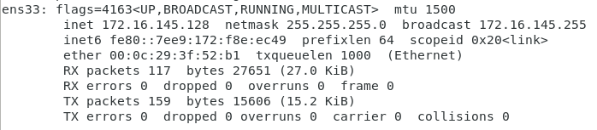

Booting back into VP0-NAT, I used the “ifconfig” command to display the network adapters and their settings. From this I can see the ens33 network adapter which is the adapter for VP0. I then powered off the virtual machine in preparation to clone VP1, VP2 and VP3.

### Network Settings for VP0-NAT

IP Address: 172.16.145.128

Default Gateway:172.16.145.254

DNS: 172.16.145.1

These addresses are automatically allocated via vmware’s own dhcp server.

#### Updated Network Diagram

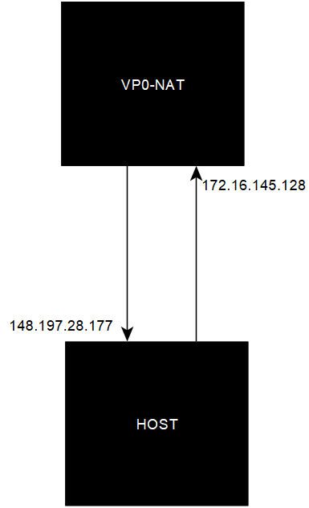

### Current Network Diagram

## Copying virtual machines

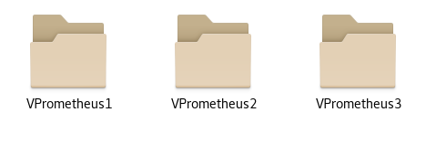

After powering off VP0, I navigated to /root/vmware where I copied the vPrometheus0 file and copied it three time renaming each file to coincide with each virtual machine, i.e., VP1, VP2 and VP3.

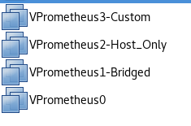

Once the VM’s were copied, I then opened them in the VMware software, changing the names of each one within their virtual machine settings. This is so I don’t have four virtual machines all named VPrometheus0.

## VP1-Bridged

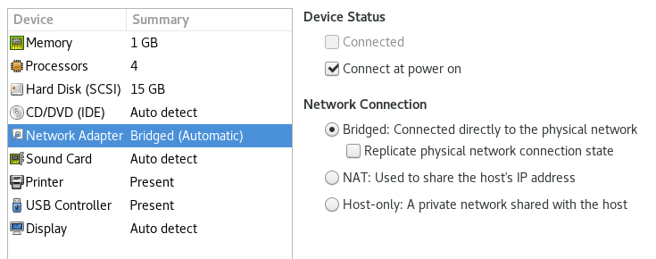

Opening the VM settings of VP1, I selected the network adapter row and changed the network connection type to bridged. This will connect the virtual machine to the network using the hosts network adapter. To enable this work, I will configure this further win the VM network settings.

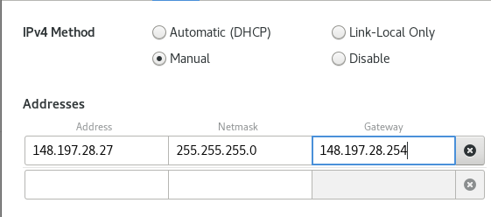

Once loaded into the virtual machine, I opened the wired settings for the network adapter and selected “manual” for the IPv4 method. The IP Address is calculated from the original host IP address minus 50. The default gateway and dns server for this machine are the same.

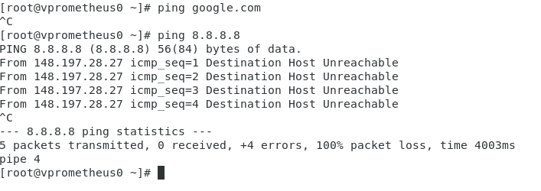

Testing the configuration, it is attempting a connection and is not throwing a “Network unknown” error which would suggest that the network settings are configured wrong. The failure in connection could mean there is a problem within the network, or the virtual machines simply need routing.



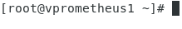

I noticed I had forgotten to change the hostname of the VP1 machine. As previously done with VP0, I used gedit to open the /etc/hostname file and then restarted the system for it to take effect.

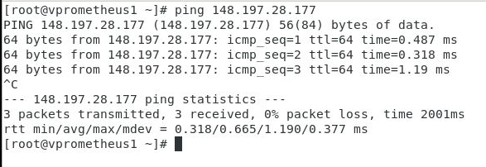

Further testing of the network shows that VP1 has the ability to ping the host showing that the network settings have been configured correctly.

#### Updated Network Diagram

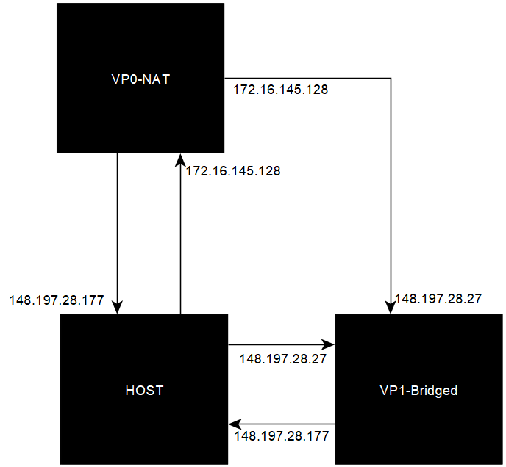

## VP2-Host_Only

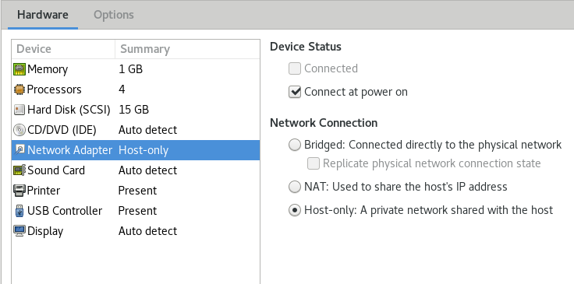

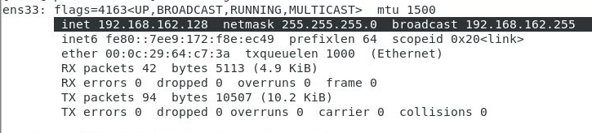

After configuring VP2 to be host only and powering the virtual machine on VMware will automatically provide the machine with an IP address from VMware’s own DHCP Server. This host only network is isolated meaning that it has no connection to anything outside of the current virtual machine

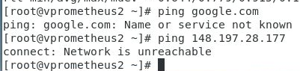

As mentioned previously, due to the host-only configuration, VP2 does not have any access outside the VM. This is shown when trying to not only ping google but also VP0.

#### Updated Network Diagram

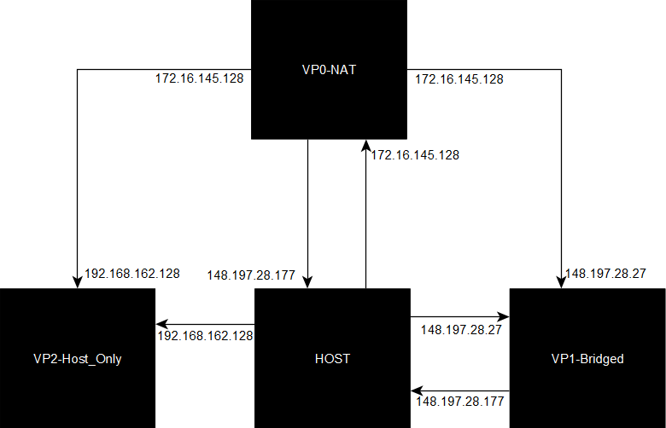

VP3-Custom

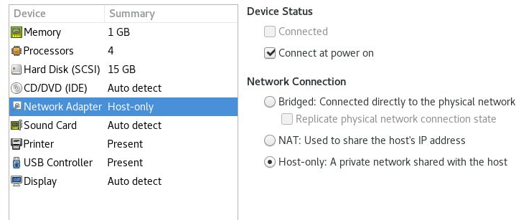

As previously done with VP1 and VP2, I also changed the network card of VP3. Firstly, I will be using this machine to test another Host-Only configuration along with further testing of the limitations of the host-only network configuration within the VMware environment.

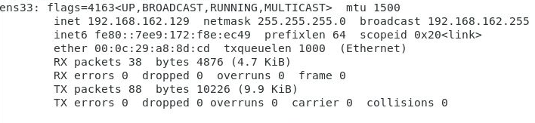

Once booted into the machine I ensured that within the network settings the IPv4 method was set to “Automatic (DHCP)” which I used with the VP2-Host_Only machine. After this I used “ifconfig” to get the IP address for VP3.

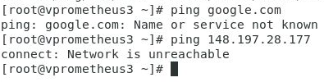

Similarly, to VP2, I still cannot ping any machine or web service outside the current network which is to be expected.

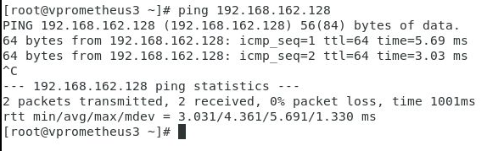

I then tried pinging VP2 from VP3 which returned successful.

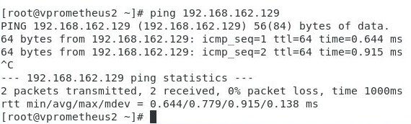

I then tried pinging VP3 from VP2 which also returned successful. The reason for this is because both machines are within the same isolated network. Although they do not have access to outside services, they do have access to any pc which is automatically assigned within VMware’s network range.

#### Update Network Diagram

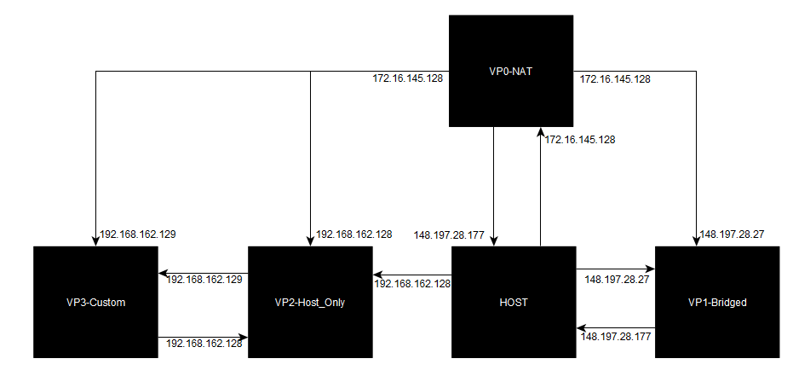

### Limitations of Host-Only Networking

## Overcoming Limitations of Host Only Networking

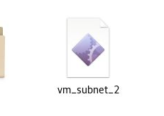

To overcome the limitations of host-only networking, I downloaded a script which will enable me to use a custom network card, vmnet2.

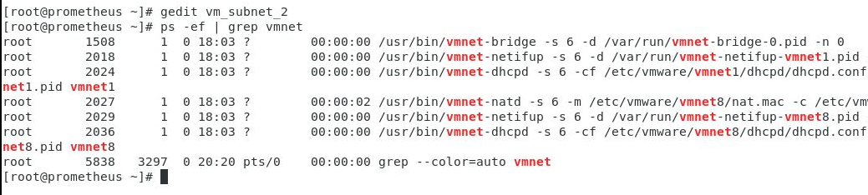

Prior to configuring this script, I used the “ps -ef | grep vmnet” to display current running process containing the keyword “vmnet”. This shows that only vmnet1 and vmnet8 are current networks used by VMware.

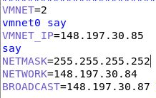

I edited this script using “gedit vm_subnet_2” 148.197.30.85 will be used for the vmnet2 adapter, for VP3 148.197.30.86 will be the IP address and 85 will be the gateway.

Custom Network Information:

Usable IP’s: 148.197.30.85 - 148.197.30.86

Netmask: 255.255.255.252 (/30 CIDR provides me with 4 addresses within the network)

Network Address: 148.197.30.84 (First Address within the network, Unusable)

Broadcast Address: 148.197.30.87 (Last address within the network, Unusable)



Prior to running the script to enable vmnet2, I used the “chmod” command to change the permissions of the vm_subnet_2 file and give it full read, write, and execute permissions.

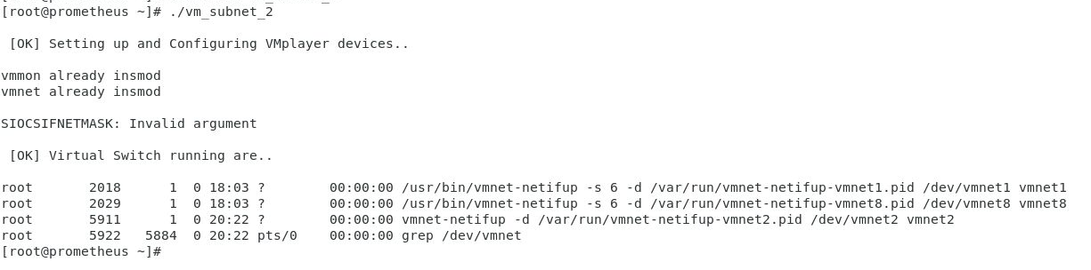

Running the vm_subnet_2 script on the virtual machine, the terminal shows that vmnet2 process is now running on the system.

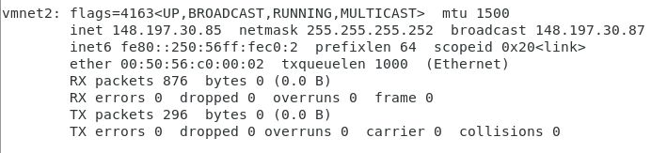

Running ifconfig confirms that this network card is now available

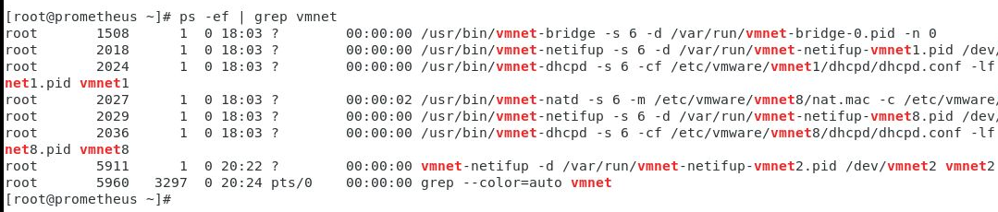

Vmnet2 now displays when displaying the current vmnet processes on the system when using the “ps -ef | grep vmnet” command.

### Fix-Vmnet-Dev

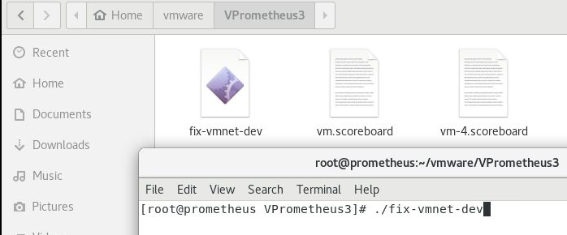

After configuring vmnet2 I then downloaded fix-vmnet-dev, another script and saved in VPrometheus3 folder. Now that I have the vmnet2 network, using the vmnet-dev script will allow me to use custom network cards within vmware.



After downloading, I tried running the script, however, permission was denied as I had forgotten to “chmod” the file as done with the subnet script.

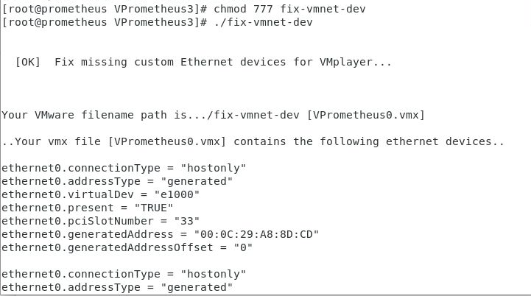

After changing the permissions of the file, I then ran the vmnet-dev script which modified the vmx file so that I would be able to use custom network adapters.

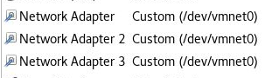

Moving back to VMware, I opened the virtual machine settings where I could see that three network adapters were available for me to use followed by “Custom (/dev/vmnet0), showing that both scripts worked

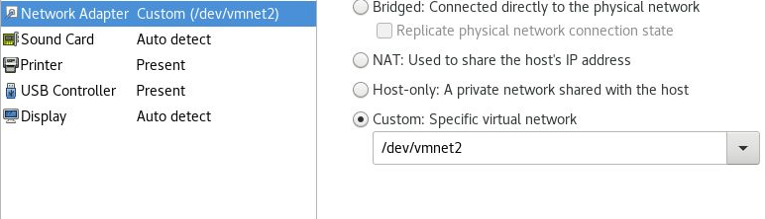

I only needed one of these so removed adapter 2 and 3 and configured the remaining adapter to use vmnet2 which was configured in the vm_subnet_2 script.

### VP3-Custom Network Settings

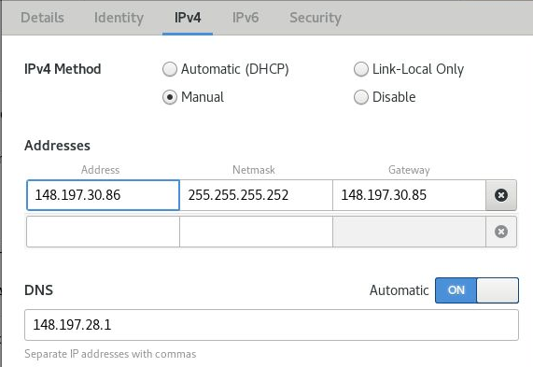

As previously specified when setting up the vm_submnet_2 script, I entered the network address, netmask, gateway and DNS.

#### VP3-Custom

IP Address: 148.197.30.86 (Second usable IP address)

Netmask: 255.255.255.252 (Netmask which provides 4 IP addresses, two which are usable)

Gateway: 148.197.30.85 (First Usable IP Address taken by vmnet2)

DNS: 148.197.28.1 (Specified DNS on host machine)

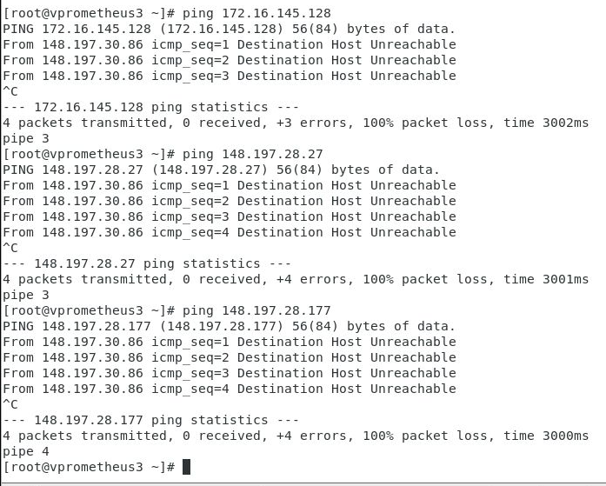

After updating the network settings to use the new IP address etc, I attempted to ping the other machines in the network. I expected pinging VP0 (172.16.145.128) to not work, however VP1 and the host I expected to work but these are both situated on the 148.197.28 network where as VP3 is on the 148.197.30 network. For these machines to connect routing is needed.

#### Updated Network Diagram

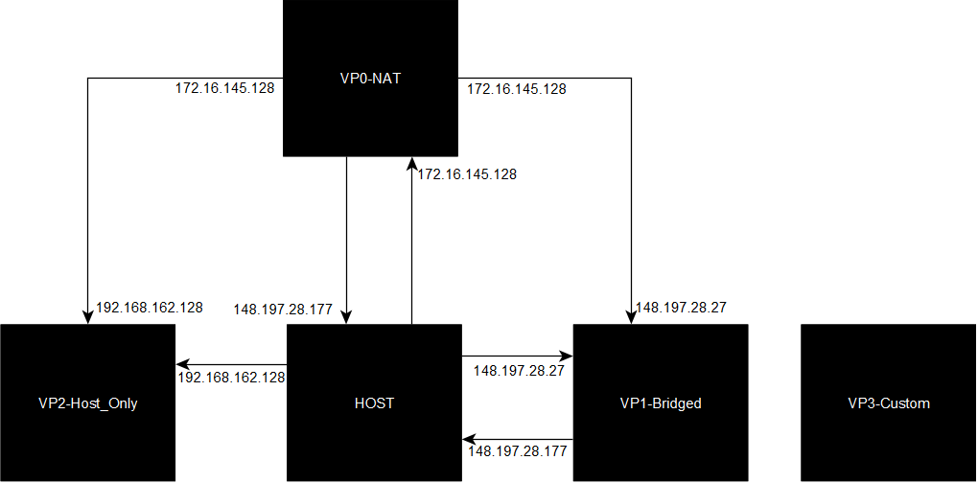

## Routing using OSPF

To fix the networking issue on VP3, I will implement routing into the network and manually configure connections between the host network and VP3’s network. This will then allow me to get an internet connection using my custom network card.

### Installing Routing Services

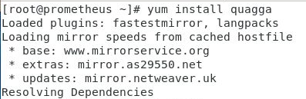

To begin routing, I first Installed the quagga service. Quagga being an architecture which takes advantage of the Open Shortest Path First (OSPF) Networking protocol, amongst others such as RIP, will allow me to setup routing within the network.

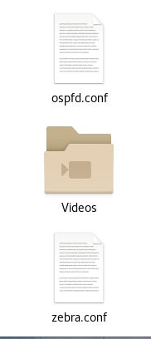

Once quagga installed onto the host system, then downloaded the ospfd.conf file and zebra.conf file. Ospfd.conf which will allow me to provide quagga with the routing settings and zebra.conf which contains the network interface settings.

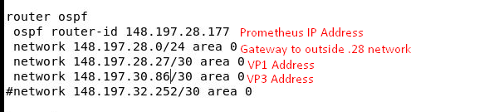

After downloading the files, I then configured the ospfd.conf file so it matched my current network setup as shown in my diagram.

Insert Zebra.Conf HERE

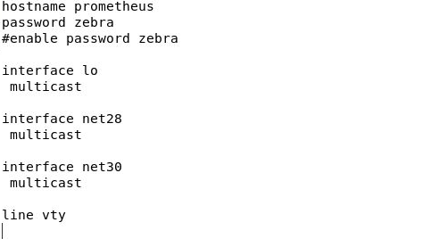

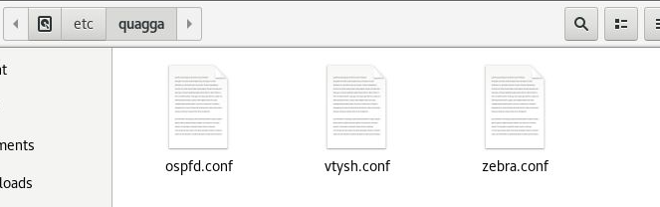

After editing both the ospfd and zebra files, I then saved them in the /etc/quagga folder. This is so the quagga service can gain access to them.

### Configuring IP Tables

Before running the routing services, I need to disable the bridged network adapter on the system. By disabling the bridged adapter, this will allow the routing to take priority and work as intended.

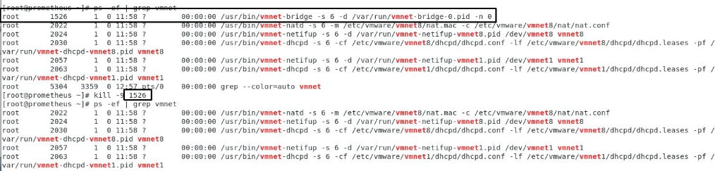  
Using the command ps -ef | grep vmnet, I can see all current processes running with the vmnet in their name.

I then disabled the bridged process for VMware using the “kill -9” command followed by the process ID, in this case 1526.

Using the grep command again, the bridge is now shutdown.

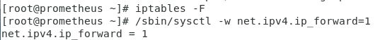

After disabling the bridge, I then moved onto disabling the firewall and enabling packet forwarding. Iptables -F flushes all network rules, i.e. any manually set rules on the system, such as something like an open port will no longer be kept and will be permanently removed.

### Testing

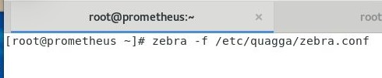

Using zebra -f /etc/quagga/zebra.conf I started the zebra service, -f in this case just specifies that I will be using a config file. This worked successfully, the terminal continued to run zebra as expected.

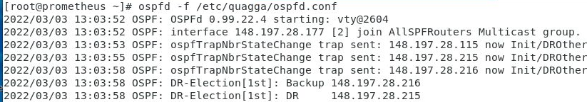

Opening another tab within the terminal window, I then used “ospfd -f /etc/quagga/ospfd.conf” to start the ospfd service. Again, similarly to zebra, this was successful and ran as expected.

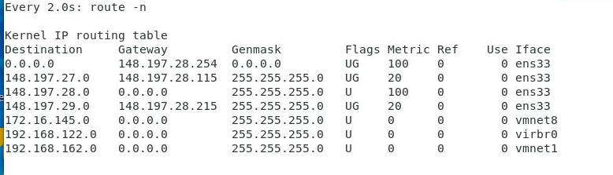

In another tab I then typed route -n which displays the routing table for the network, here it can be seen that there is a connection between the .28 network and .29 network, displayed by the metric, showing that routing has been successful.

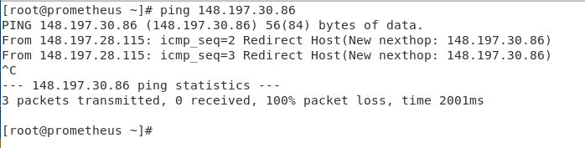

After checking if there was a successful connection using route -n, I then tried pinging VP3 from Prometheus which was successful as it displayed the hops to the new network however this showed packets were not being received back from VP3 and there was 100% packet loss.

### Fixing routing issue

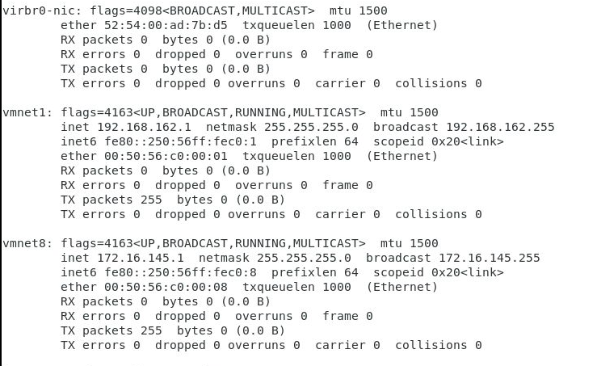

Taking a look at the ifconfig on the system, I found that vmnet1 and 8 were running on the system but vmnet2 the network interface being used for VP3 was down.

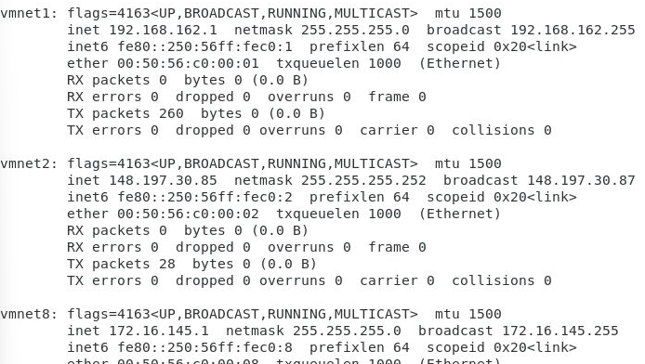

I restarted the vmnet2 interface on the system, the reason this was down is because it doesn’t automatically start after the system has been shutdown.

### Re-testing

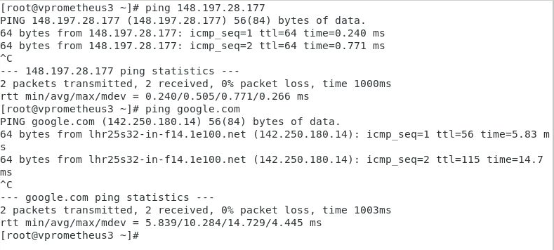

After restarting vmnet2 I can now ping the host machine and google from VP3 with 0% packet loss.

# VMware Conclusion

# Virtual Box Virtual Machines

## Installation of Virtual Box

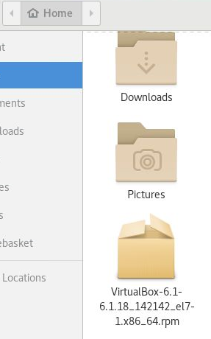

Before setting up my virtual box network, I firstly downloaded Virtual Box.

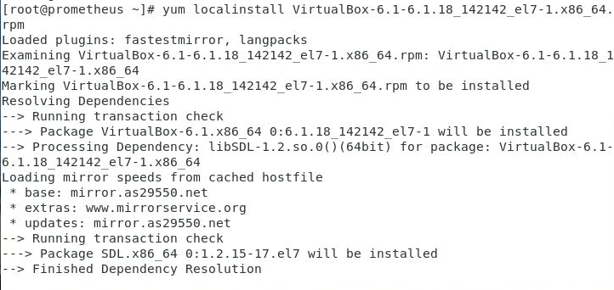

I then used the “yum install” command followed by the name of the virtual box .rpm file I had just downloaded to Install Virtual box onto the system.

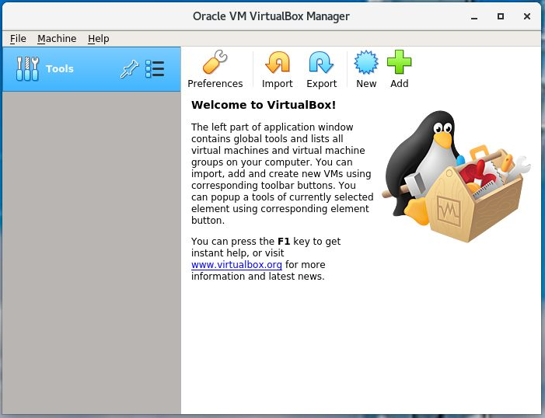

Once Virtual box fully installed I opened the application to check that it was installed correctly.

## Building a Virtual Machine

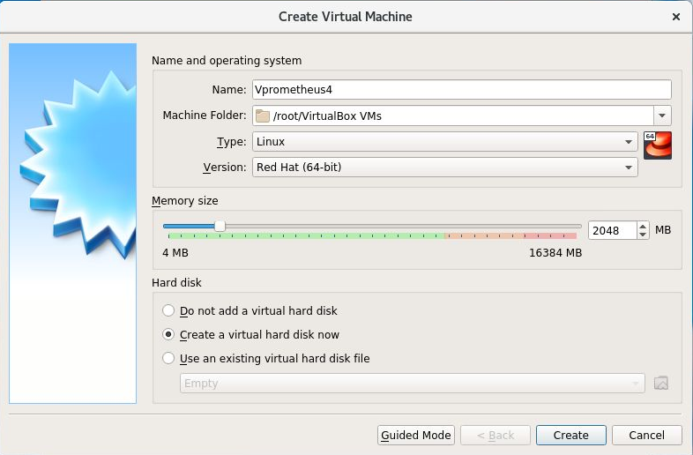

I then began creating VP4, I entered expert mode as it would give me more control over the virtual machine settings. I gave the virtual machine the name Vprometheus4, selected Red Hat (64-bit) as the version of linux as I will be installing CentOS7 onto it which is based off Red Hat and selected create a virtual hard disk now.

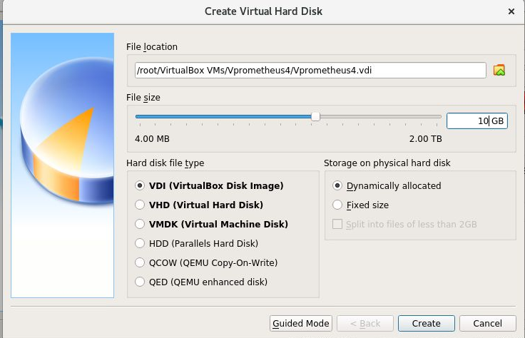

In the next menu, I selected VDI and set the storage to be dynamically allocated. Dynamic allocation means that the system won’t take up the space unless it needs it, i.e. even though the system has been allocated 10gb it will not reserve that 10gb from the host system.

VDI

VDI or Virtual Disk Image is the default file type used by virtualbox. Any disks created within virtual box will have the .vdi extension which allows dynamic or fixed sized storage and can also be used within other virtualisation software such as VMware.

VHD

VHD or Virtual Hard Disk created for the use of Microsoft virtualisation products stores up to 2TB of data. This file type also can remain a fixed size or dynamically extend to the amount of data the user has on the system. This file type has also now been replaced by vhdx which can hold up to 64TB and is the default storage medium for Microsoft Hyper-V hypervisor.

VMDK

The Virtual Machine Disk (VMDK) is most likely the most common out of the three virtual hard disk formats. Originally created for use with VMware products, i.e. player, workstation and fusion, VMDK is supported within VirtualBox. Similarly to VHD, when it was first created VMDK could only store 2TB of data, however, this limit is now 62TB and can also be dynamic or fixed.

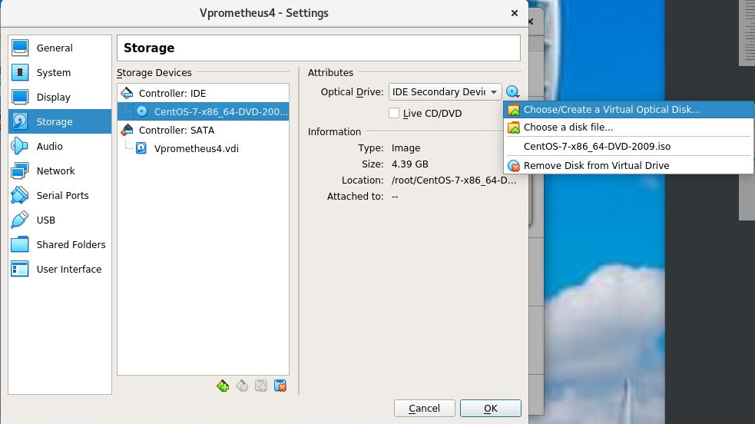

After creating the virtual machine I then moved into the settings of the virtual machine itself, selected storage and set the optical medic to use the CentOS7 iso on the system by selecting the blue disk in the top right of the window, selecting choose/create a vritual optical disk and navigating to the .iso file on the system.

I then started the virtual machine and begun the installation of CentOS.

### Installing CentOS

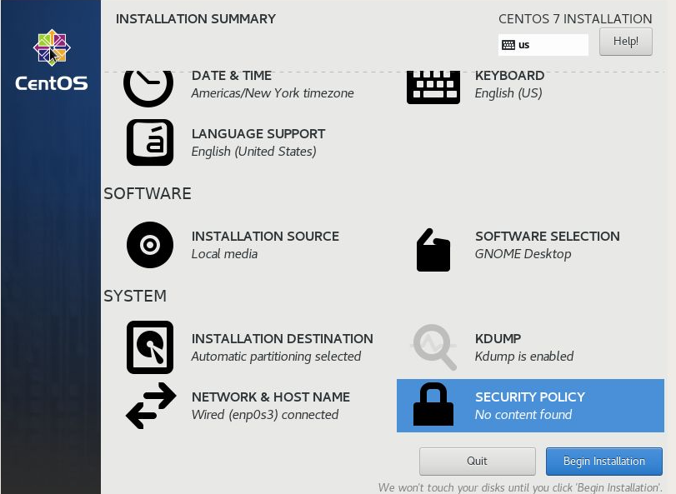

Within the CentOS7 Installation manager, I configured the Installation destination selecting automatic partitioning, network and hostname, configuring the hostname of the system and also the root password and user creation sections in the next section.

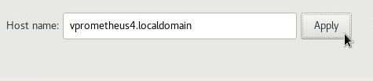

For the hostname, the default is set to localhost.localdomain, I renamed this to vprometheus4.localdomain and selected apply.

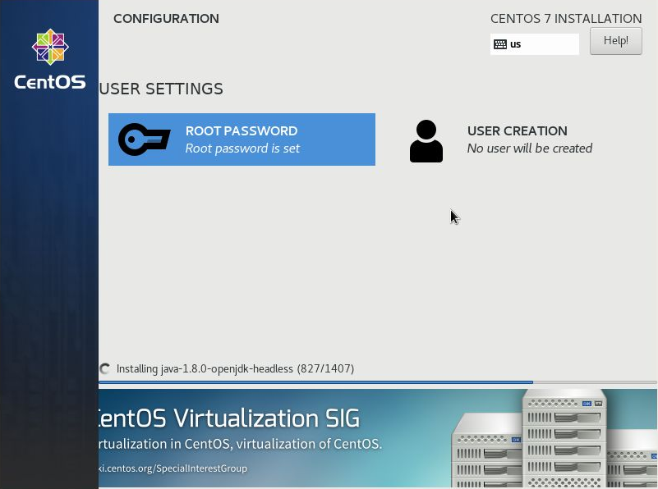

While the system was installing CentOS I created a standard user account and root password for the system.

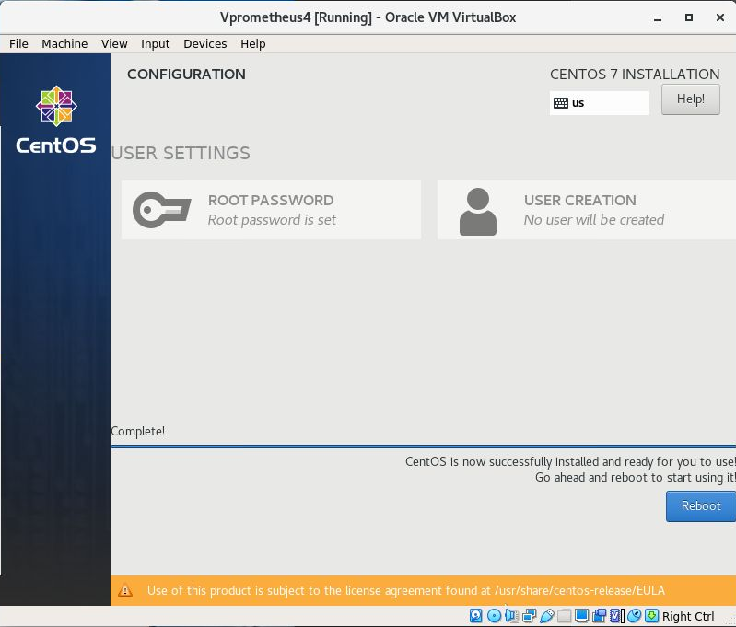

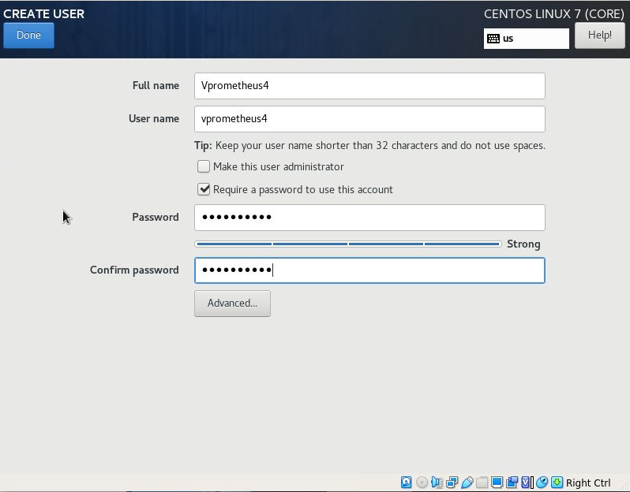

I set the username of the standard user account to Vprometheus4 and left the “make this user administrator box unchecked” as I will be using the root account instead of this user.

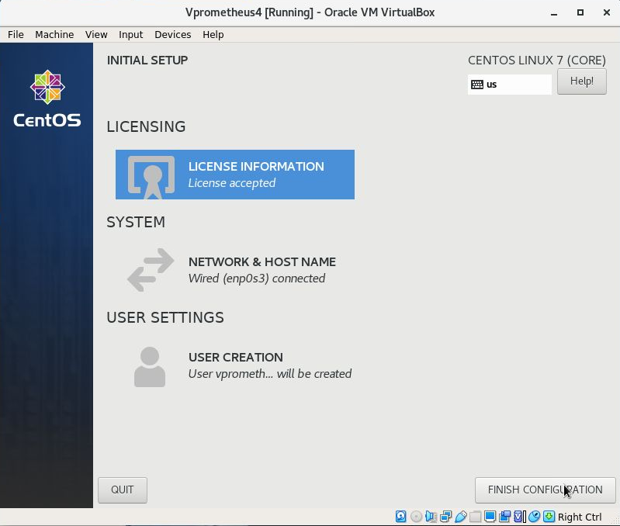

Once everything was setup and installed, I selected finish configuration and the system rebooted into linux.

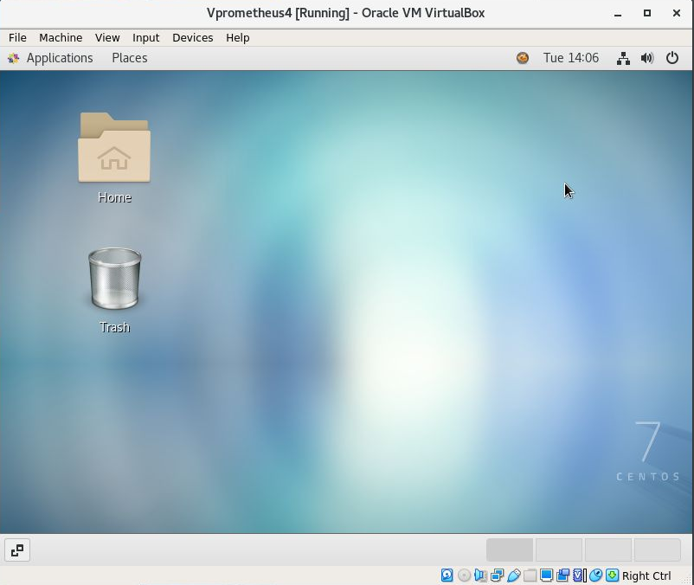

VP4 with CentOS7 successfully installed

### VP4 Network Settings

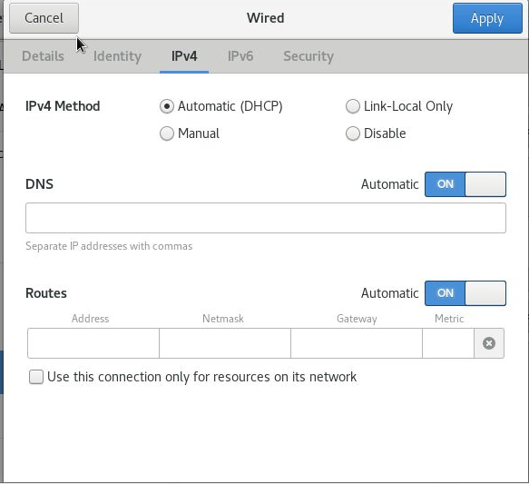

After booting into the VM, I opened the wired settings ensuring the IPv4 method being used for VP4 is Automatic as this is the NAT machine.

### Testing

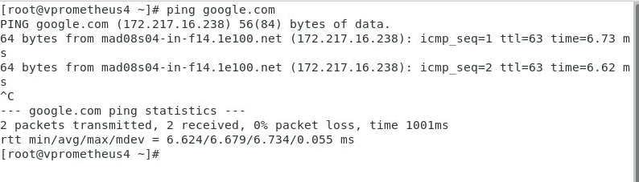

As expected VP4 has internet access

Is the machine as functional as a standard computer?

## Virtual box and Machine Settings

### Virtual media manager

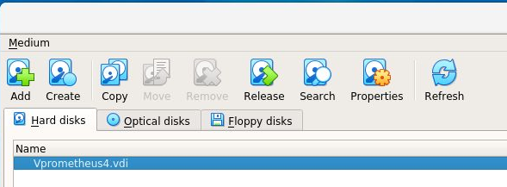

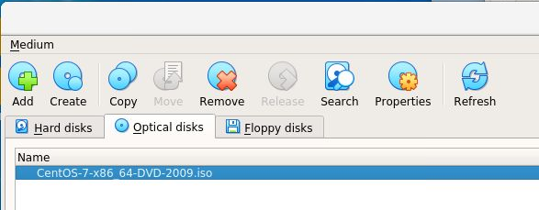

### Host Network Manager

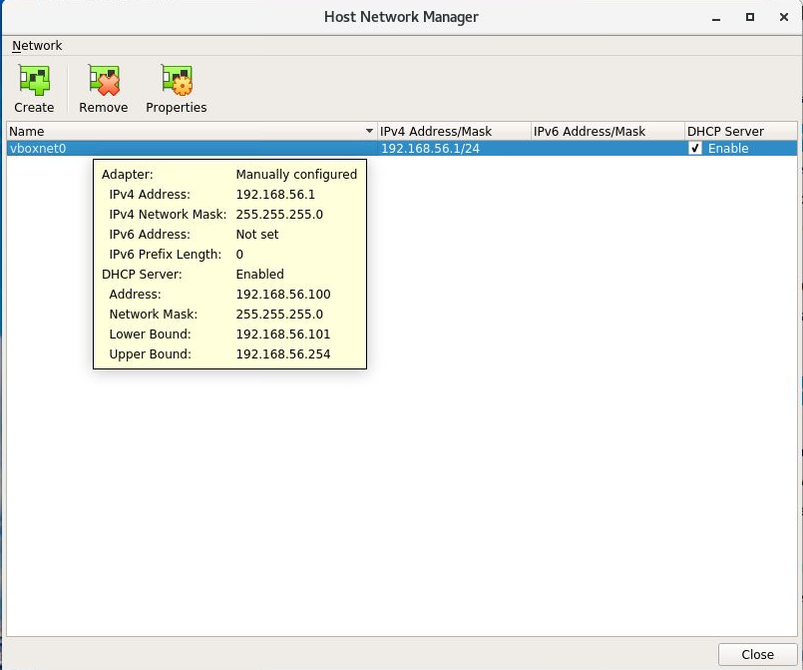

Configure custom network cards, similar to vmware

## VM Settings

### General – Disk encryption

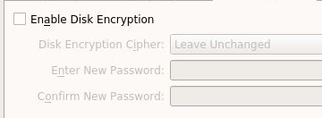

Within the general section of the virtual machine settings, the disk encryption tab contains a section where the user can encrypt the disk of the VM making it only accessible via a password.

### Display – Remote display

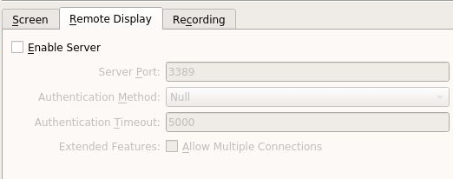

### Network – Adapter Settings

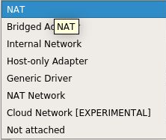

Users can choose from an array of adapter types from the usual NAT, Bridged and Host-Only which are found on VMware to an experimental cloud network adapter. This gives more options to configuring and testing networks.

### Shared Folders

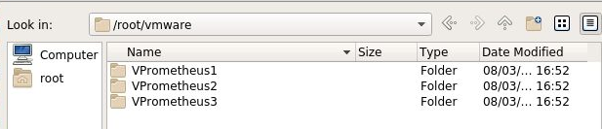

Allows the user to add one or multiple shared folders which can be accessed by the host and the user of the virtual machine. For example, I could give vp5 access to vp1-3.

### User Interface

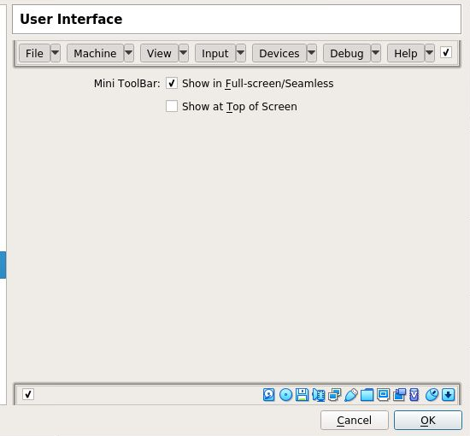

Allows the user to change the look of the UI when using the virtual machine. The user can choose if they would like the hot bars to be shown and what they would like shown.

## Virtualbox Networking

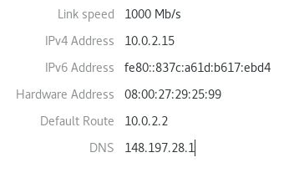

Vprometheus4 network adapter settings

IP Address: 10.10.2.15

Default Gateway: 10.0.2.2

DNS server: 148.197.28.1

DNS is taken from the host machine. IP address and gateway are both allocated by virtual box DHCP server like VMware.

### Setting up VBox network

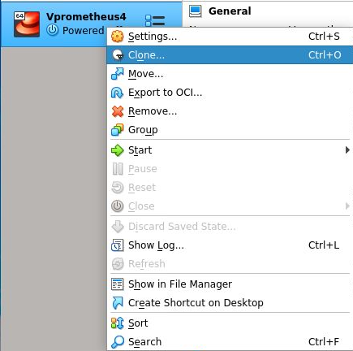

Using the cloning option within virtual box I copied the machine to create 3 more versions of the same machine.

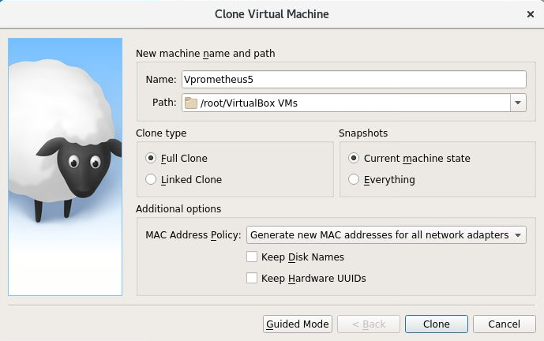

For each clone I increased the number within the name by one and changed the mac address policy to generate a new mac address so the machines could be differentiated.

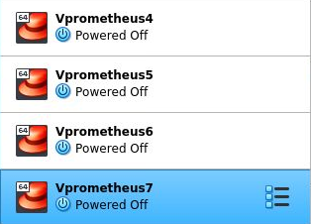

I then followed the same cloning process two more times, changing the name and generating new mac addresses for all network adapter giving me a total of four machines. This then builds the base for my virtual box network.

### Renaming virtual machines

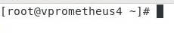

As the machines have been cloned, the name is still vpromethus4 within the terminal for each machine. For Vpromethus5-7 I will edit the /etc/hostname file renaming them accordingly.

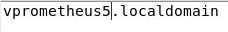





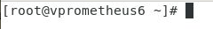



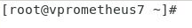

Virtual machines 5-7 renamed accordingly.

## Virtualbox Manager Experimentation

In this section I will be looking at settings and how it affects the virtual machine.

### VP4-NAT

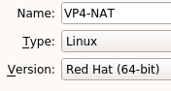

To begin, I changed name of Vprometheus4 within VirtualBox Manager to VP4-NAT.

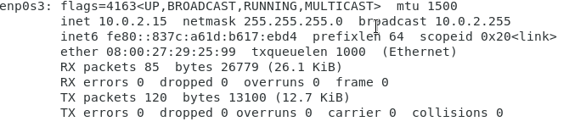

Using ifconfig, I retrieved the current network configurations. In this case, for VP4, my enp0s3 adapter shows IP Address: 10.10.2.15 Subnet: 255.255.255.0 Broadcast:10.0.2.255

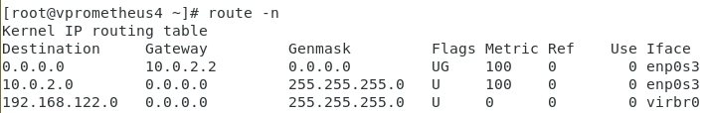

Using the route -n command then displays that the default gateway for this system is 10.0.2.2

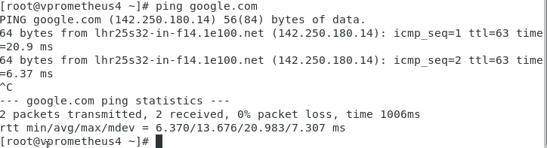

Using the default network configuration on VP4-NAT, I was able to successfully ping to google.com.

### VP5-Bridged

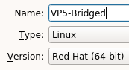

Like VP4, I changed name of Vprometheus5 to VP5-Bridged.

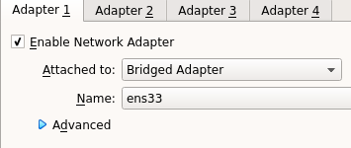

Once the name was set, I then changed the network adapter of VP5 to Bridged adapter, this means that it will use an address on the host network. Now that this is configured, I will need to change the IPv4 settings within the virtual machine to match with the host network.

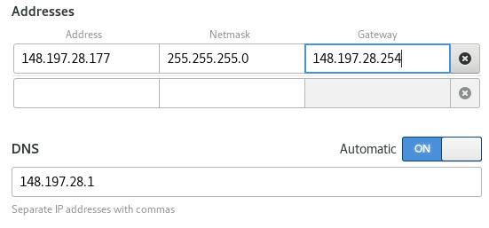

Configuring the IPv4 settings for VP5, the IP address for this machine is the original host IP address (148.197.28.77) plus 1 (148.197.28.78).

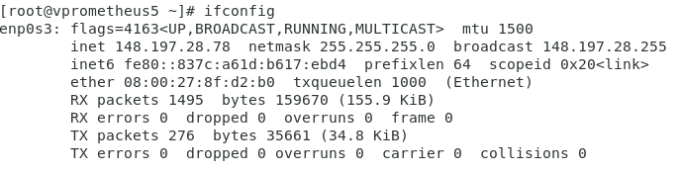

After changing the IP I used the ifconfig command to check if the IP change had taken place which it did.

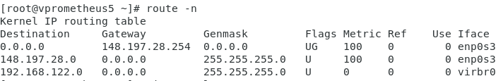

Using the route -n command I also checked the gateway for VP5 which has changed to 148.197.28.254 as specified in the network settings

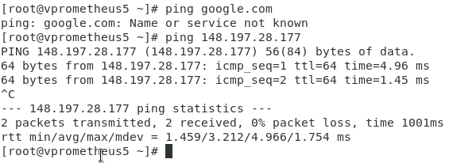

When testing these network settings, trying to ping google fails, however, I am able to ping 148.197.28.177. Similarly, to VP3, routing needs to be carried out to allow connection to outside networks.

### VP6-Host Only

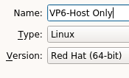

Moving onto Vprometheus 6, I changed the name to VP6-Host Only.

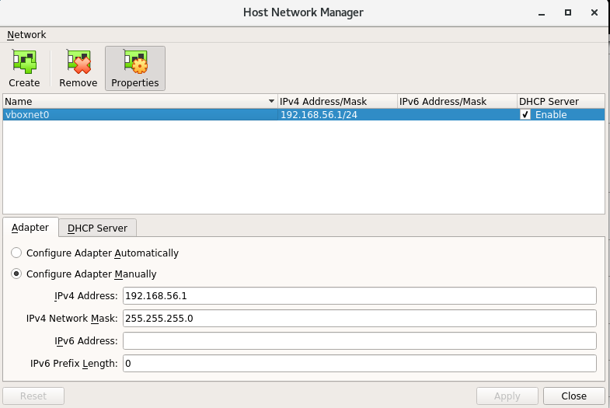

After changing the name I then opened the Host network manager and created a custom network card. At this point I left the IPv4 address as 192.168.56.1 which was automatically assigned by virtual box and enabled the DHCP server.

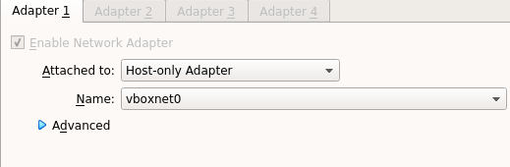

After settings up the custom network card, I changed to a host only adapter and selected the vboxnet0 network card.

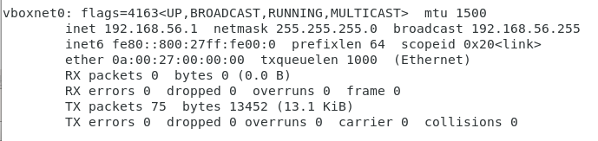

After starting the VP6 virtual machine, vboxnet0 network card can be seen when entering ifconfig into a terminal on the host to display the network.

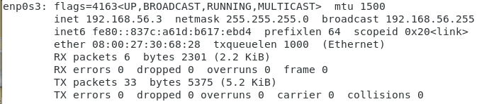

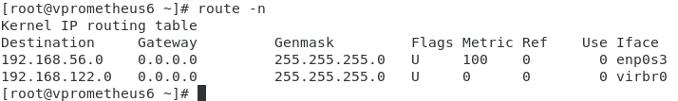

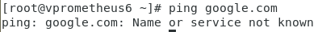

When trying to ping google.com from VP6, “Name or service not known” displays, this is because the virtual machine does not have an internet connection.



Similarly, VP6 cannot ping Prometheus as it is on a different network to the host network.

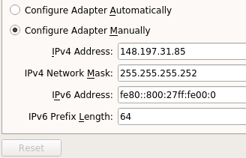

After using the standard settings for vboxnet0, I then opened the host network manager window again and re-configured the settings. This time I setup the adapter to match with my host IP address but VP6 will on the .31 subnet.

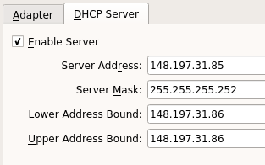

After setting up the adapter, I then customised the vboxnet0 DHCP Server settings to match. 255.255.255.252 is used in this case as I only have 4 IP addresses, two of which are not usable hence why my server address is .85 and both my upper and lower bound addresses are .86.



These network settings are based off pre-determined IP address ranges.

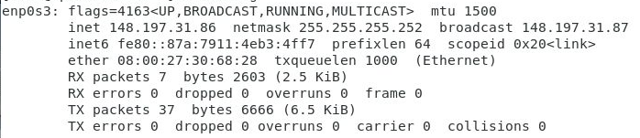

Moving back into the VP6 virtual machine and entering the ifconfig command, I can see the updated network information. Here I can also see that the broadcast address is the correct address.

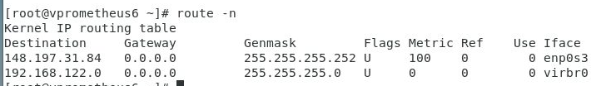

Using the route -n I can also see that the network address is also correct with an address of 148.197.31.84.

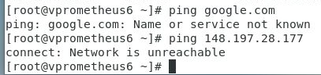

After setting up the network card, I tried to ping google, but due to vp6 being host only this still shows “Name or service not known”. Also VP6 cannot ping prometheus as it on different subnet. VP6 is on .31 subnet where as prometheus is on .28.

### VP7-Internal

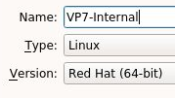

As done with the previous 3 virtual machines, I changed the name of Vprometheus7, renaming it to VP7-Internal.

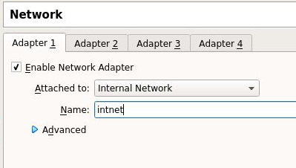

Moving into the settings of VP7, I then changed the network adapter to internal network, and kept the name as the automatically assigned “intnet”.

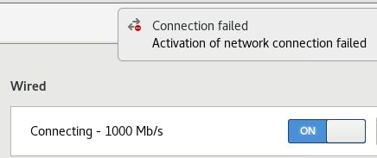

After booting into the virtual machine, a connection failed error can be seen at the top left of the machine, showing that VP7 has no connection to the network.

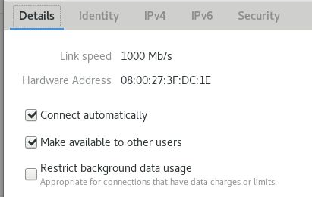

Looking at the network adapter settings, this is automatically set to automatic DHCP, however, no IP address, broadcast address or netmask has been assigned by the virtualbox DHCP server.

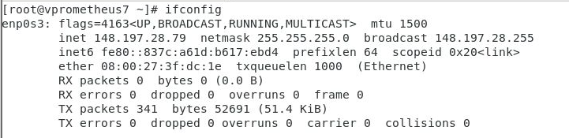

As the network was not configured, I manually entered the IPv4 address 148.197.28.79, so that this machine would be on the same network as the host machine. Using ifconfig I could then see that the changes had taken place.

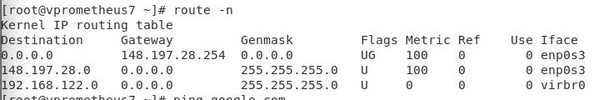

Using route -n I could see that vp7 was infact showing a gateway and metric values suggesting a connection to the host machine.

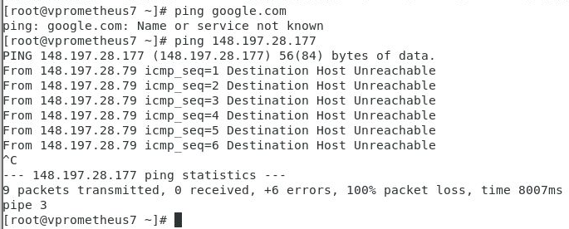

When testing this, a ping to google was unsuccessful and when pinging prometheus, even though on the same network the ping fails.

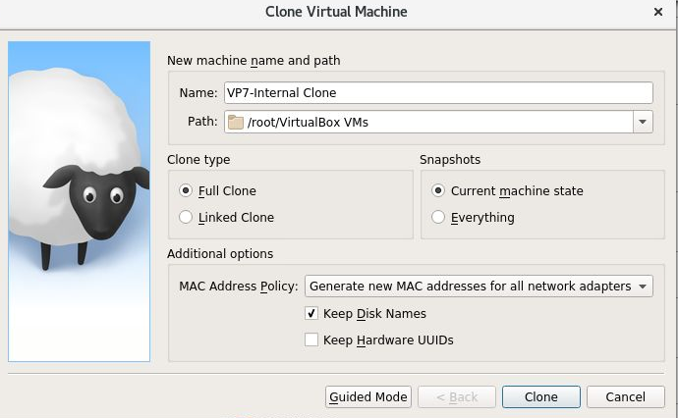

Following the failure to ping on the same network, I created another machine, generating new mac addresses for the network adapters.

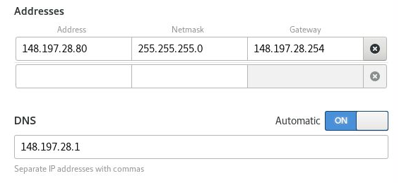

After starting the VP7 clone, I then edited the network settings so the machine would be on the same network as VP7 but would be plus 1.

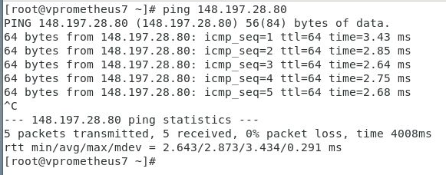

I then tried pinging the VP7 clone from VP7 which returned successful.

## Differences Between VMware and VirtualBox

In comparison to VMware, VirtualBox is a much simpler virtualisation software, although still encompassing some impressive features. Features such as shared folders, remote display and a multitude of network adapters provide the user with plenty of options when it comes to how they set up their virtual machine or network.

The features of VirtualBox lack in comparison to VMware’s which is rich with machine specific options which include those in the VirtualBox client. The ability to setup AutoProtect in VMware which automatically creates a given snapshots within a given time frame surpasses the alternate option on VirtualBox where any snapshot must be done manually which can easily be forgotten.

Even simple options are automatically disabled in VirtualBox such as the ability drag files from the host system into the VM or use content from the hosts clipboard and vice versa; options which are automatically enabled in VMware to provide a better user experience.

With regards to UI customisation, VirtualBox has much more customisation where you are able to choose what you would like displayed on your bottom status bar and on the top bar when in a VM or if you would like these shown at all. Not only this but within the drop-down menus on the top bar you can also customise what options are available in each of the drop downs. VMware does not have this level of customisation, some options are removable, however these are options to quickly take a snapshot, enter full screen and entering different modes which can be useful when in a VM.

When using both pieces of software to setup virtual networks, I found VMware overall more intuitive in comparison. Vmware seems to be better optimised when running a multitude of operating systems and even running simple operating system such as CentOS. Running multiple virtual machines on VMware is faster than VirtualBox and setting up these virtual machines is also easier. The cloning process on VirtualBox is done manually through the software, right clicking and cloning each virtual machine. VMware just requires file to be copied, renamed (which happens automatically I.e. copy(1).) and then run in the client.

Looking at networking, both hypervisors allow the user to configure network adapters. Experimenting with this, I found that VirtualBox offered more options in comparison to VMware however both hypervisors allowed for the use of custom network cards opening the networking possibilities of VMware significantly. However, as standard, VirtualBox comes with options such as internal networks and experimental cloud networks, allowing the user to configure intranet scenarios and cloud computing environments from within the hypervisor which is an option VMware does not include as standard.

# Virtual Box Conclusion